**Exercise 7.1:** Download and examine [SortedList.java](http://www2.seas.gwu.edu/~simhaweb/java/modules/module7/examples/SortedList.java). Draw a complete memory picture after the first threePerson instances have been inserted. Then, trace through what happens on the *stack* all the way from main() to when the fourth Person. instance in added to the list.

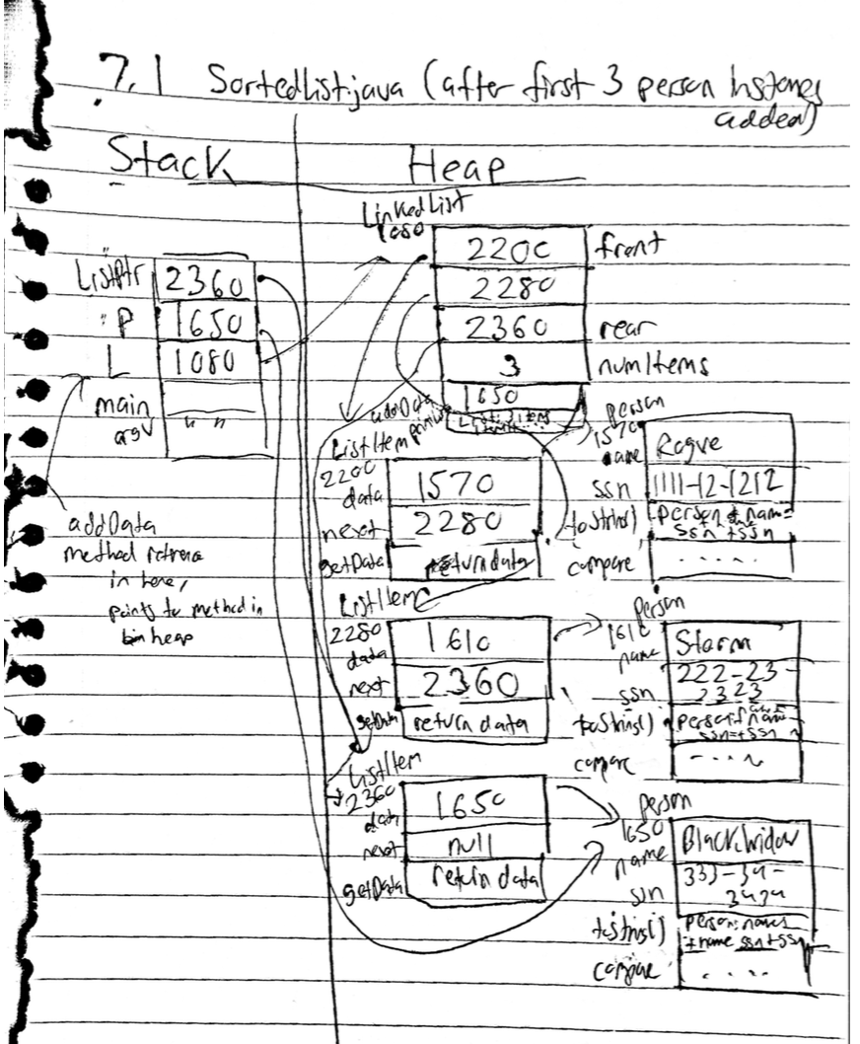

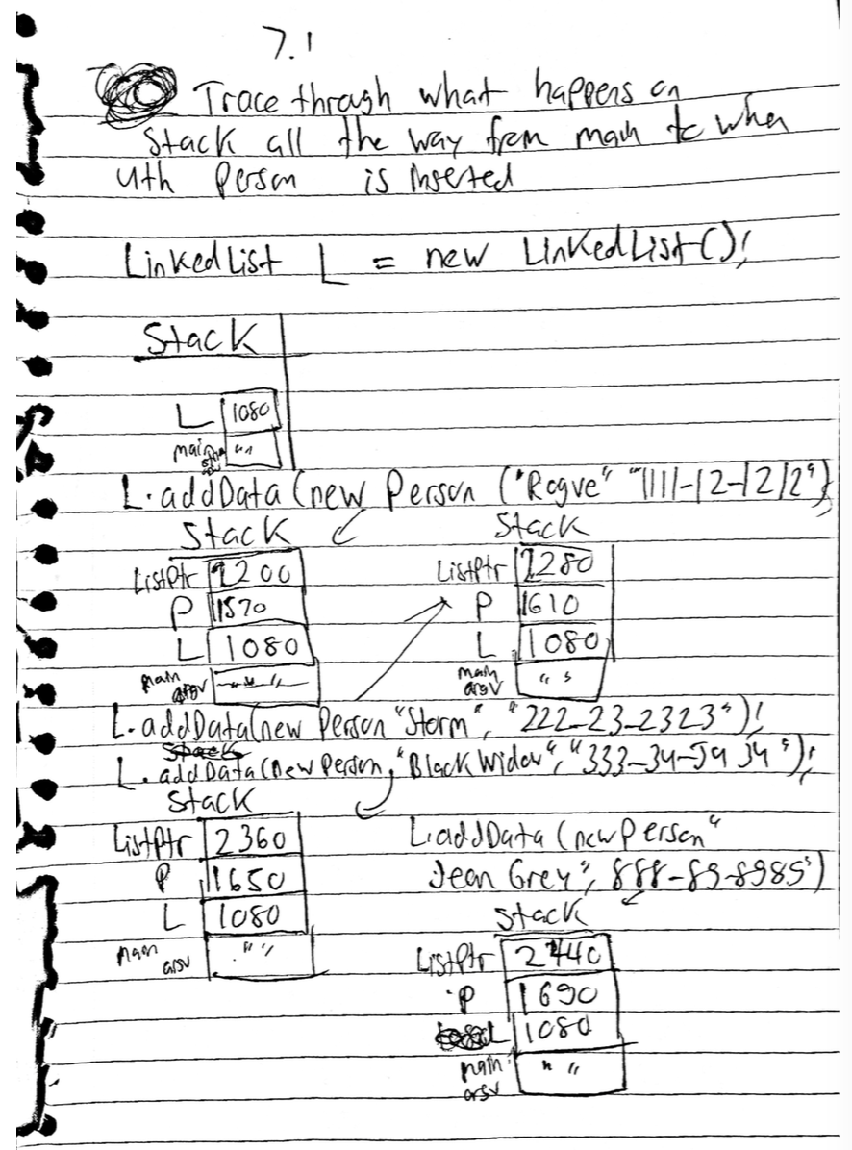

**Exercise 7.2:** Download and examine the [above program](http://www2.seas.gwu.edu/~simhaweb/java/modules/module7/examples/SortedList3.java). Draw a complete memory picture at the beginning of the while-loop in main(). What is the variable e pointing to?

The variable e is pointing to a ListEnumerator object in the heap.

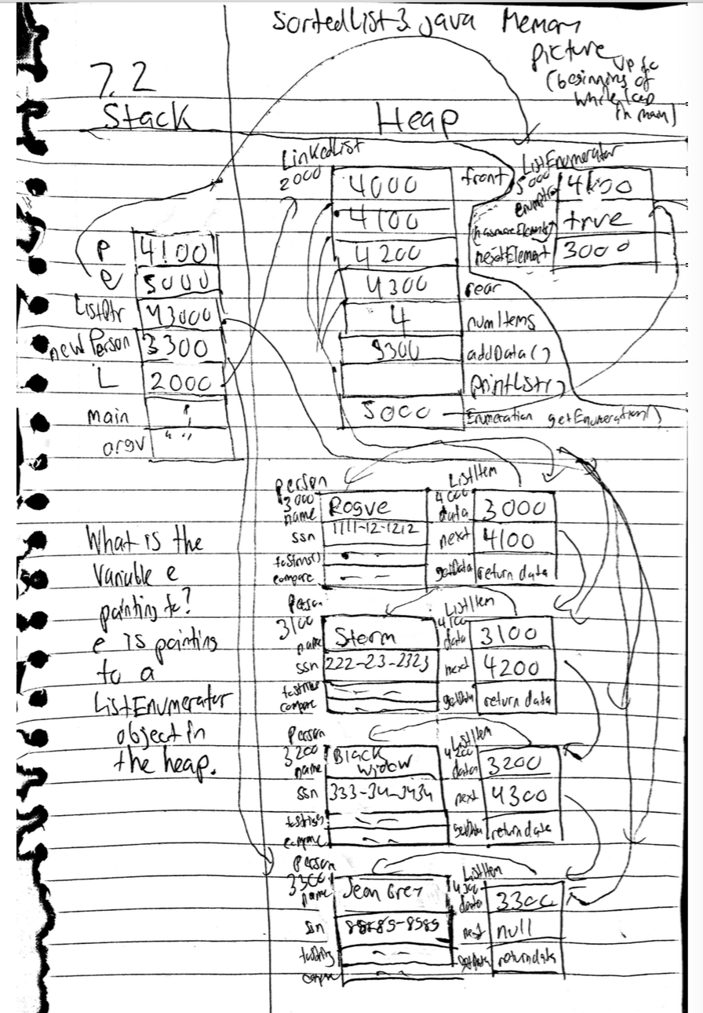

**Exercise 7.3:** Download and examine the [above program](http://www2.seas.gwu.edu/~simhaweb/java/modules/module7/examples/SortedList4.java). Draw a complete memory picture at the beginning of the while-loop in main(). What is the variable e pointing to?

The variable e is pointing to a listItem.

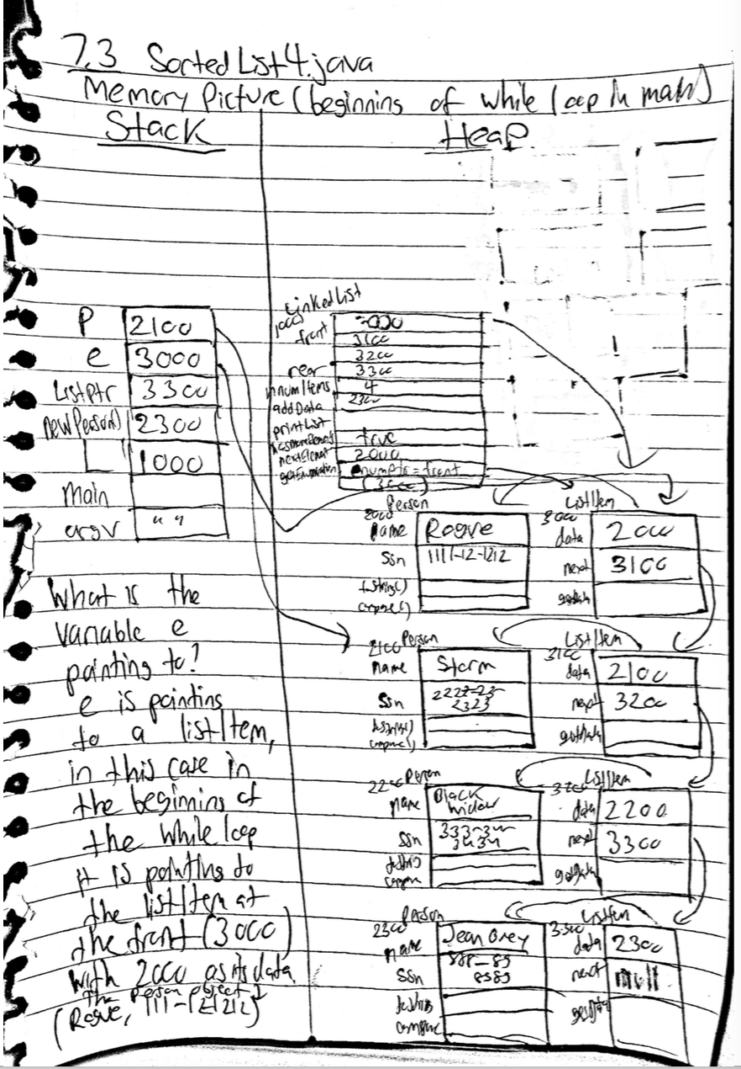

**Exercise 7.6:** Download, compile and execute the [above program](http://www2.seas.gwu.edu/~simhaweb/java/modules/module7/examples/SortedList6.java). Draw a complete memory picture to show why this doesn't work.

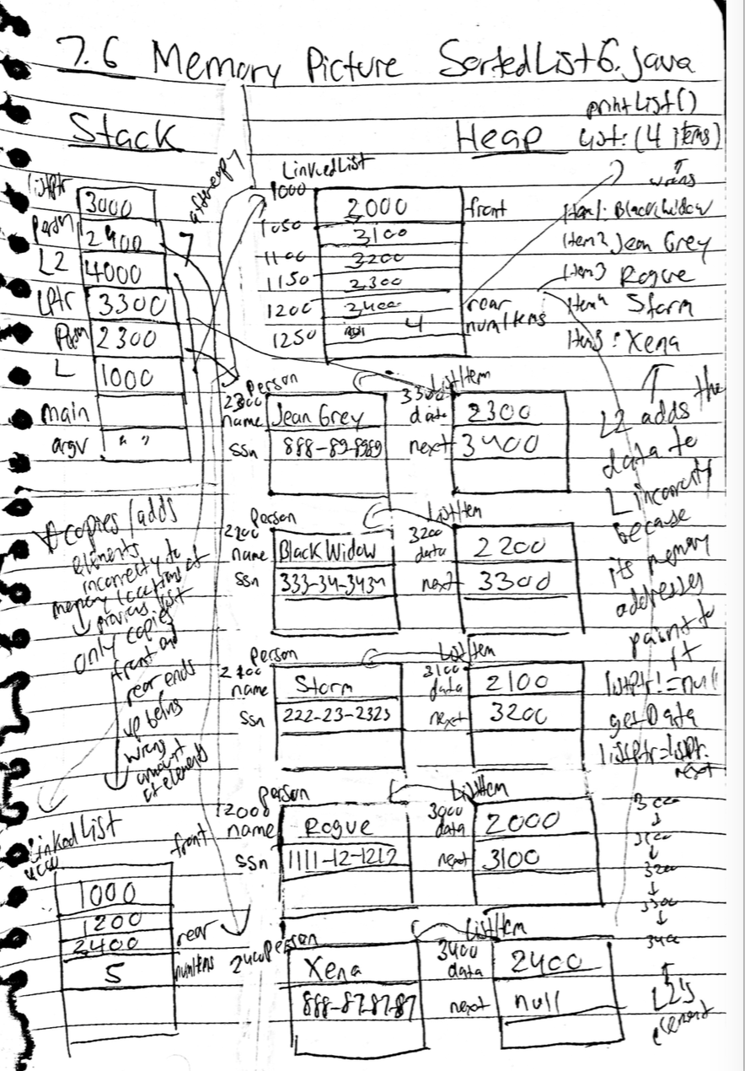

**Exercise 7.7:** The complete source with the above changes is available [here](http://www2.seas.gwu.edu/~simhaweb/java/modules/module7/examples/SortedList7.java). Compile and execute to see what happens. What do you observe? Write code to fix the problem.

The compiler cannot find the symbol “p” because p wasn’t instantiated. Creating a new instance of person fixes this, the problem with the code is that the number of items are not updated. To fix this, the remove method should update the number of elements in the list and also it should set the appropriate links to the surrounding elements. In addition to this, the L2 instance of the LinkedList is changed by the blank out method when it shouldn’t be.